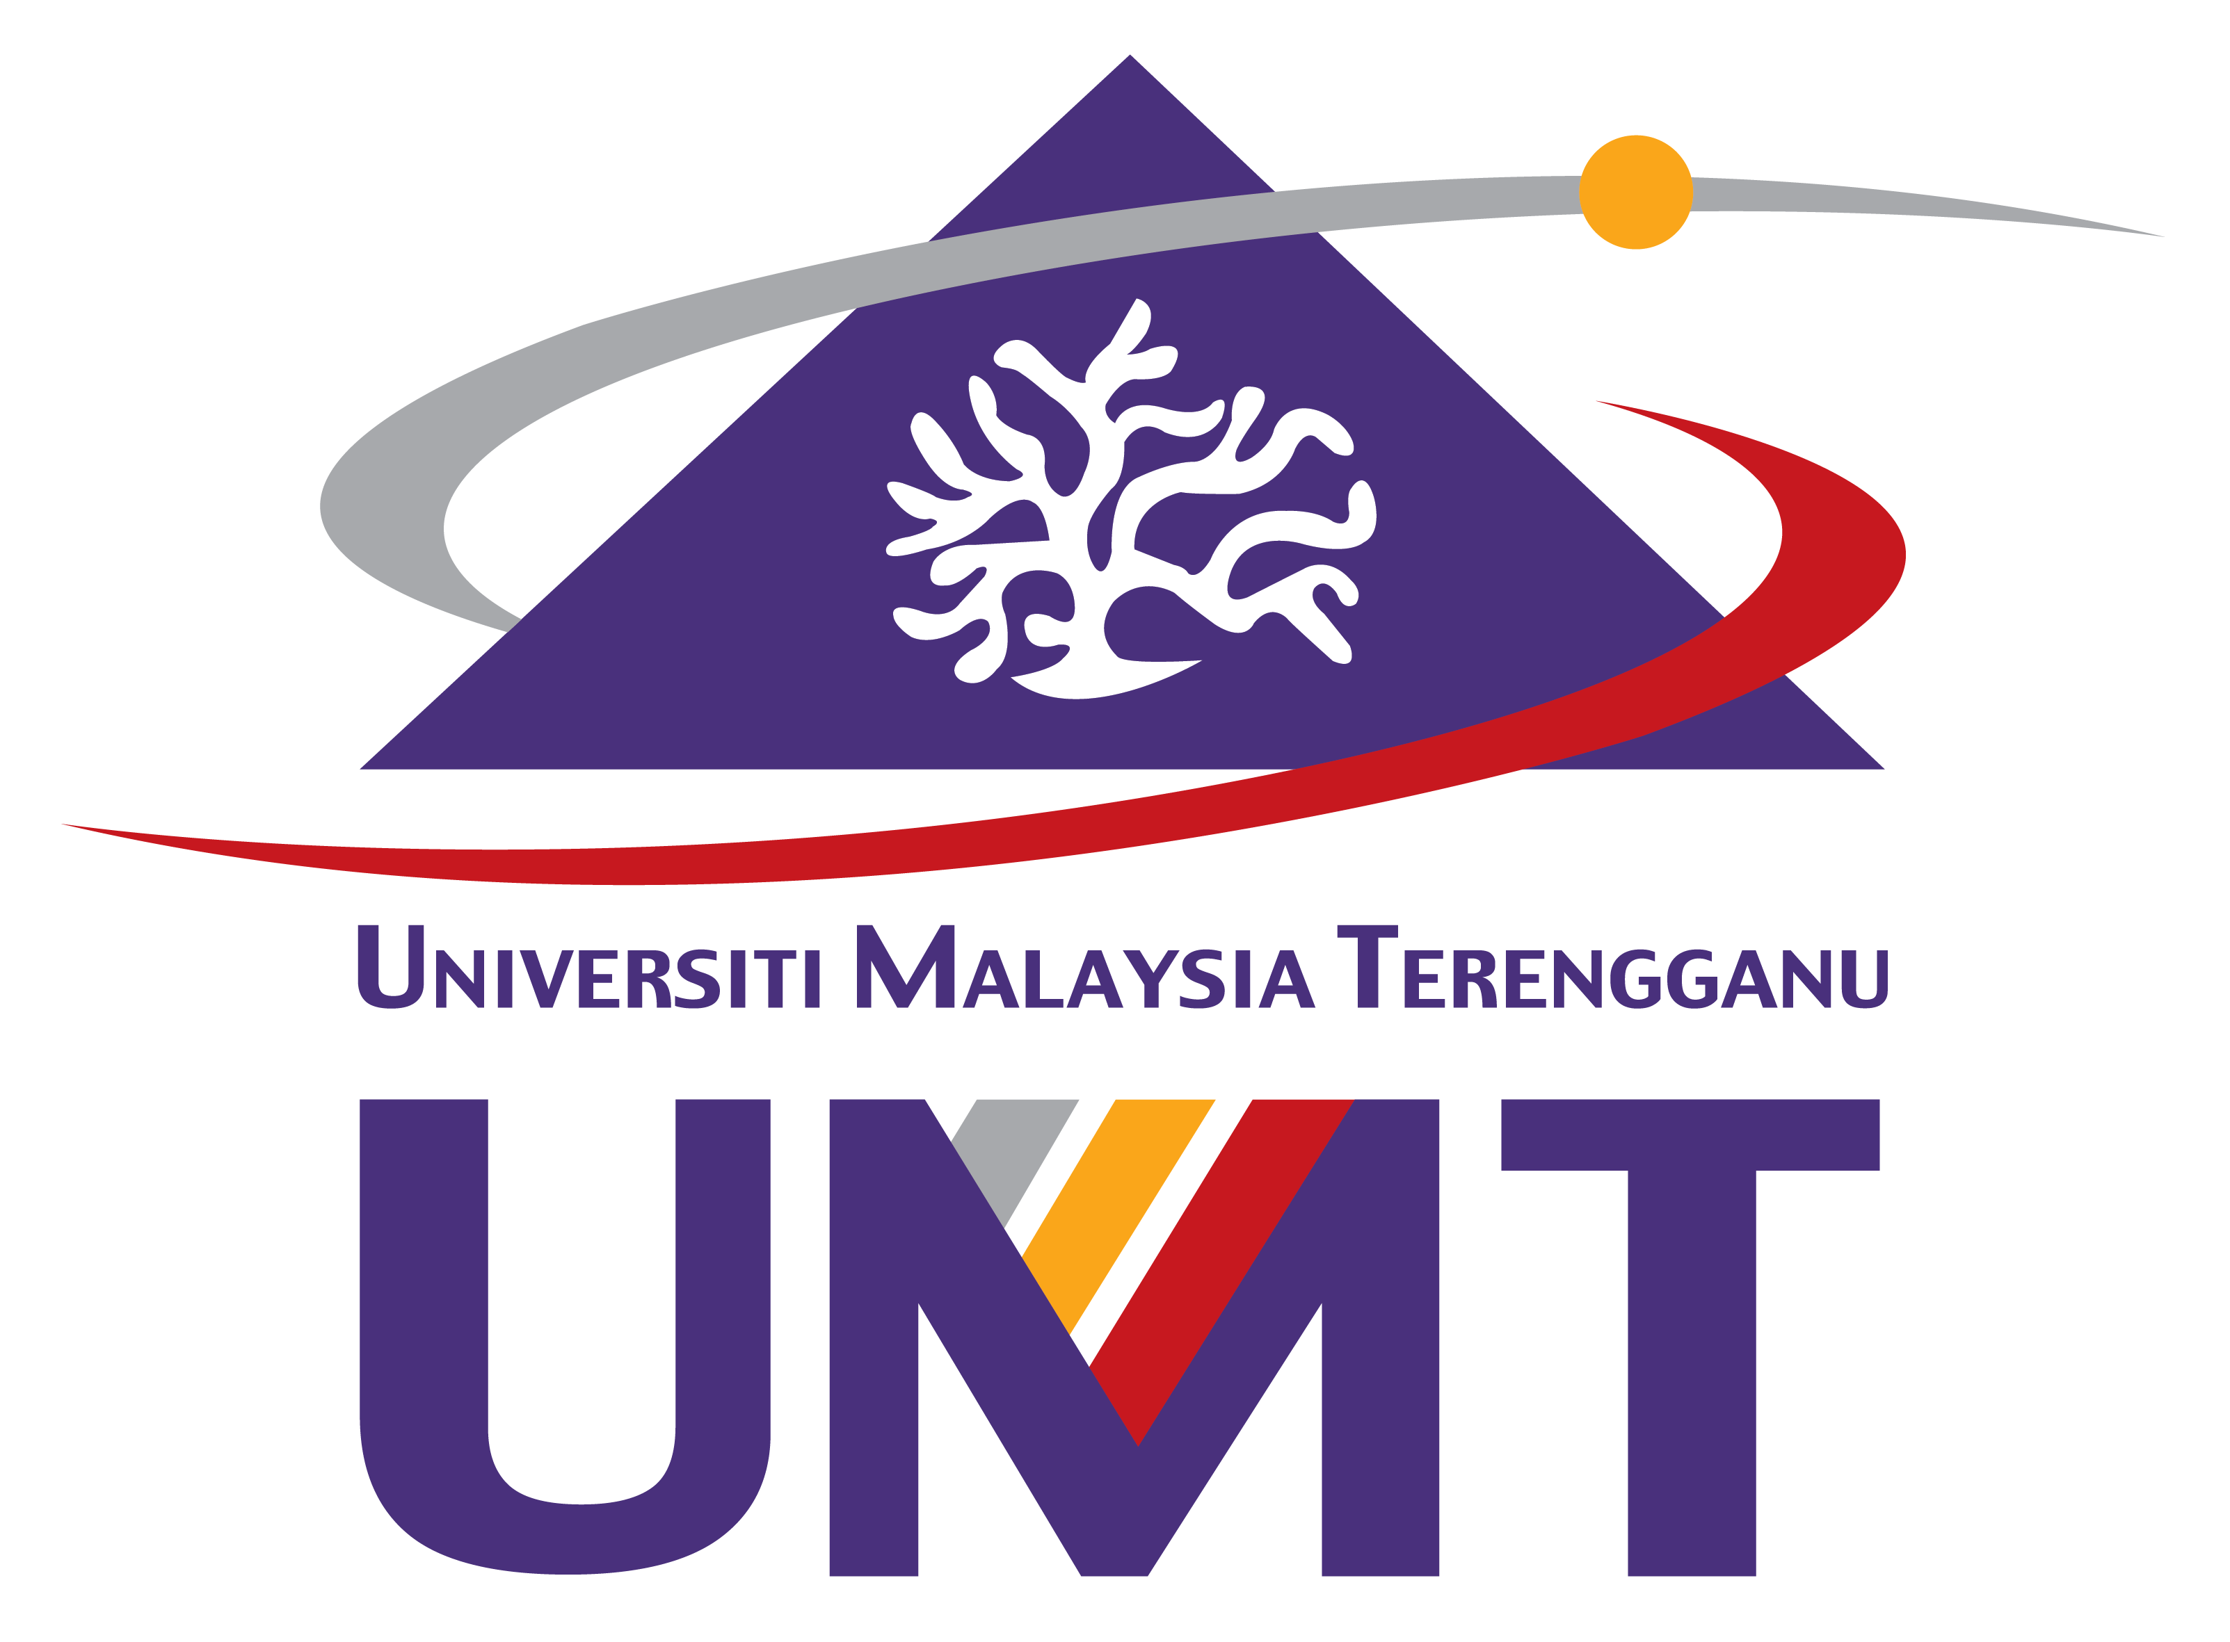
UMT/B/PG-09 (Pind.1/2025)
UNIVERSITI MALAYSIA TERENGGANU
21030 Kuala Nerus
Terengganu, Malaysia.

PERMOHONAN PELANJUTAN TEMPOH MAKSIMUM PENGAJIAN STRUKTUR PENYELIDIKAN

APPLICATION TO EXTEND MAXIMUM PERIOD OF STUDY FOR RESEARCH STRUCTURE

 | Nota:  Note: | Borang ini hendaklah diisi dengan HURUF BESAR dihantar ke Fakulti/Institut/Pusat  This form is to be filled in CAPITAL LETTERS and submitted to the respective Faculty/Institute/Centre
BAHAGIAN A  PART A |  |  | UNTUK DILENGKAPKAN OLEH PELAJAR  TO BE COMPLETED BY STUDENT

1. | Nama Penuh:  Full Name:
2. | No. Matrik:  Matric No: |  |  | 3. | Program:  Programme: | Sarjana  Master |  | Doktor Falsafah  Doctor of Philosophy

4. | Mod Pengajian Semester Semasa:  Mode of Study in Current Semester: | Sepenuh Masa  Full Time |  | Separuh Masa  Part Time

5. | Fakulti/Institut/Pusat:  Faculty/Institute/Centre: |  | 6.. | Bil. Semester Berdaftar:  No. of Registered Semester:

7. | Semester Semasa:  Current Semester: | 1 |  | 2 |  |  |  | Sesi:  Session:

8. | Permohonan pelanjutan kali ke berapa?  Application of extension for the _________: |  |  |  |  | Kali Pertama  First Time |  |  |  |  | Kali Kedua  Second Time
9. | Semester Pelanjutan:  Extension Semester: | 1 |  | 2 |  |  |  |  | Sesi:  Session:

10. |  | Justifikasi pelanjutan (lampirkan dokumen sokongan,jika berkaitan):  Justification for extension (attach supporting documents, if any):
 |  |  |  | Tandatangan Pelajar:  Signature of Student: |  | Tarikh:  Date:

BAHAGIAN B  PART B | SOKONGAN PENYELIA UTAMA  RECOMMENDATION OF MAIN SUPERVISOR

Disokong  Recommended |  |  | Tidak disokong  Not recommended

Ulasan:
Comment(s):

 |  | Tandatangan dan Cop Rasmi:  Signature and Official Stamp: |  | Tarikh:  Date:

BAHAGIAN C  PART C | UNTUK KEGUNAAN PEJABAT  FOR OFFICE USE

 | Tarikh Terima  Received Date |  | Tandatangan & Cop Rasmi  Signature & Official Stamp
 | Tarikh Semakan  Checking Date |  | Tandatangan & Cop Rasmi  Signature & Official Stamp

GARIS PANDUAN PERMOHONAN PELANJUTAN TEMPOH MAKSIMUM PENGAJIAN STRUKTUR PENYELIDIKAN
GUIDELINES FOR APPLICATION TO EXTEND MAXIMUM PERIOD OF STUDY FOR RESEARCH STRUCTURE
1. | Permohonan pelanjutan tempoh maksimum pengajian struktur penyelidikan perlu dibuat selewat-lewatnya tiga (3) bulan sebelum tamat tempoh maksimum pengajian.  Application to extend the maximum period of study for research structure need to be submitted no later than three (3) months before the end of the maksimum period of study.
2. | Permohonan perlu dibuat dengan menggunakan Borang Permohonan Pelanjutan Tempoh Maksimum Pengajian Struktur Penyelidikan (UMT/B/PG-09) yang boleh diperolehi dari portal pelajar atau laman web pengajian pascasiswazah (https://postgrad.umt.edu.my/form/).  Application need to be made using the Application Form to Extend the Maximum Period of Study for Research Structure available from the student portal or postgraduate studies website (https://postgrad.umt.edu.my/form/).
3. | Pelajar perlu mengemukakan permohonan lengkap melalui Penyelia Utama untuk kelulusan Jawatankuasa Pengajian Siswazah Fakulti/Institut/Pusat.  The student is required to submit the complete application through the Main Supervisor for approval of Postgraduate Studies Committee of the Faculty/Institute/Centre.
4. | Kelulusan pelanjutan boleh diberikan sebanyak dua (2) kali sahaja iaitu sebanyak satu (1) semester untuk satu (1) kali permohonan.  Approval for extension can be given for two (2) times only, one (1) semester for each time application.
5. | Sebarang rayuan untuk melanjutkan tempoh selepas pelanjutan dua (2) semester diberi, tidak akan dipertimbangkan.  Any further appeal after an extension of two (2) semesters has been given, will not be considered.

